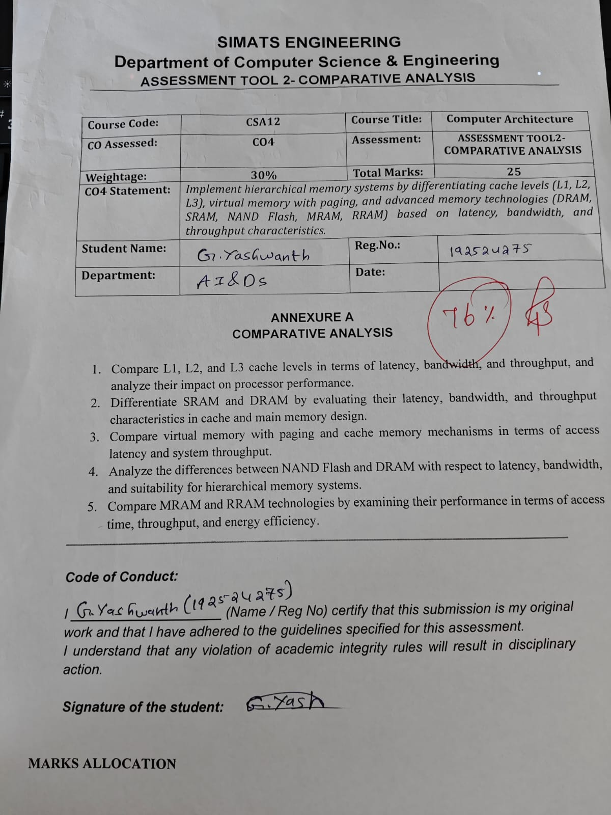



1. Comparison of L1, L2 and L3 Cache
L1, L2 and L3 are different levels of cache memory used to reduce the time required by the CPU to access frequently used data.
Feature | L1 Cache | L2 Cache | L3 Cache
Latency | Very low | Low | Higher
Bandwidth | Very high | High | Moderate
Throughput | Very high | High | Moderate
Size | Small | Medium | Large
Location | Inside CPU core | Near CPU core | Shared among cores
Speed | Fastest | Fast | Slower than L1 and L2
Analysis:.
L1 cache has the lowest latency and highest bandwidth, so it provides the fastest access to frequently used data. L2 cache is larger but slightly slower. L3 cache is the largest and is generally shared between CPU cores. All three levels improve processor performance by reducing the number of accesses to slower main memory. Therefore, a higher cache hit rate results in better processor throughput

2. Comparison of SRAM and DRAM
SRAM and DRAM are two important types of semiconductor memory. SRAM is mainly used for cache memory, while DRAM is used for main memory.
Feature | SRAM | DRAM
Latency | Very low | Higher
Bandwidth | High | High
Throughput | High | High
Speed | Faster | Slower
Refresh | Not required | Required
Cost | Expensive | Less expensive
Capacity | Smaller | Larger
Application | Cache memory | Main memory
Analysis:
SRAM provides faster access because it does not require periodic refreshing. Therefore, it is suitable for L1, L2 and L3 caches. DRAM has higher latency but provides greater storage capacity at a lower cost. Hence, DRAM is suitable for main memory. SRAM improves CPU performance, while DRAM provides the required large memory capacity.

3. Virtual Memory with Paging vs Cache Memory
Virtual memory and cache memory both improve system operation, but they serve different purposes.
Feature | Virtual Memory with Paging | Cache Memory
Main purpose | Increases available memory | Speeds up memory access
Latency | High | Very low
Bandwidth | Lower | Very high
Throughput | Can decrease during page faults | Generally improves
Managed by | Operating system | Hardware
Storage used | RAM and secondary storage | SRAM
Main benefit | Supports large programs | Reduces CPU waiting time
Analysis:
Cache memory stores frequently accessed data close to the CPU and provides very low access latency. Virtual memory uses paging to move data between RAM and secondary storage when required. A cache hit provides fast access, whereas a page fault can cause significant delay because data must be retrieved from storage. Therefore, cache memory mainly improves system speed and throughput, while virtual memory increases the usable memory space.

4. Comparison of NAND Flash and DRAM
NAND Flash and DRAM are used at different levels of the memory hierarchy. DRAM is used as main memory, whereas NAND Flash is mainly used for permanent storage.

Feature | NAND Flash | DRAM
Latency | Higher | Lower
Bandwidth | High | Very high
Throughput | High | Very high
Data retention | Non-volatile | Volatile
Refresh | Not required | Required
Capacity | Very high | High
Main application | SSD and storage | Main memory
Analysis:
DRAM provides faster access and high bandwidth, making it suitable for frequently accessed working data. NAND Flash has higher latency but provides high capacity and retains data without power. Therefore, DRAM is placed closer to the CPU, while NAND Flash is used for long-term storage.

5. Comparison of MRAM and RRAM
MRAM and RRAM are emerging non-volatile memory technologies that can provide fast access while retaining data without power.
Feature | MRAM | RRAM
Access time | Very low | Very low
Throughput | High | High
Energy efficiency | High | Very high
Volatility | Non-volatile | Non-volatile
Endurance | Very high | High
Density | High | Very high
Main advantage | Fast and durable | High density and low power
Analysis:
MRAM stores information using magnetic states and provides fast access with high endurance. RRAM stores information by changing the resistance of a material and can provide high density with low energy consumption. MRAM is suitable for applications requiring fast and reliable memory, while RRAM is promising for high-density and energy-efficient memory systems.

Overall Conclusion
The comparison shows that L1 cache and SRAM provide the lowest latency, while DRAM provides larger main memory capacity. NAND Flash provides high-capacity non-volatile storage. Virtual memory increases the usable memory space, whereas cache memory improves access speed. Emerging technologies such as MRAM and RRAM provide promising alternatives for future high-performance and energy-efficient memory systems.

